
North Lake Senior Campus
Semester 1 Examination, 2014
Question/Answer Booklet

PHYSICS
Stage 2 2014
Name: ___________________________________
Teacher: Solutions

Time allowed for this paper
Reading time before commencing work: Ten minutes
Working time for paper: Two and a half hours
Material required/recommended for this paper
To be provided by the supervisor
This Question/Answer Booklet
Physics Formulae, Constants and Data Sheet
To be provided by the candidate
Standard Items: Pens, pencil, eraser, correction fluid, ruler, highlighter
Special Items: MATHOMAT and/or Mathaid, drawing compass, protractor, set square and calculators satisfying the conditions set by the Curriculum Council for this subject.
Important note to candidates
No other items may be taken into the examination room. It is your responsibility to ensure that you do not have any unauthorised notes or other items of a non-personal nature in the examination room. If you have any unauthorised material with you, hand it to the supervisor before reading any further.
Structure of this paper

Section | Number of questions | Suggested Time (minutes) | Number of questions to be answered | Marks available | Percentage of exam
A: Short Answers | 13 | 60 | ALL | 57 | 44
B: Problem Solving | 6 | 70 | ALL | 58 | 45
C: Comprehension and Data Analysis | 1 | 20 | ALL | 15 | 12
 |  |  | Total | 130 | 100%
Instructions to candidates
- The rules for the conduct of Western Australian external examinations are detailed in the Year 12 Information Handbook 2010. Sitting this examination implies that you agree to abide by these rules.
- Write your answers in this Question/Answer Booklet.
- Working or reasoning should be shown clearly when calculating or estimating answers.
- You must be careful to confine your responses to the specific questions asked and to follow any instructions that are specific to a particular question.
- Spare pages (p26-28) are included at the end of this booklet. They can be used for planning your responses and/or as additional space if required to continue an answer.
- Planning: If you use the spare pages for planning, indicate this clearly at the top of the page.
- Continuing an answer: If you need to use the space to continue an answer, indicate in the original answer space where the answer is continued, i.e. give the page number.
Fill in the number of the question(s) that you are continuing to answer at the top of the page.

Section One: Short answers 45% (58 Marks)
This section has 13 questions. Answer all questions. Write your answers in the space provided.
Suggested working time: 60 minutes

- Why is there a rule that university research students are never allowed to eat or drink in a Science laboratory where radioactive isotopes are being used? Be specific about what the precise dangers are and why. [3 marks]
Eating could result in ingestion of radioative material [1]
This exposes soft tissue to radiation [1]
soft tissue is particularly vulnerable to radiation damage (even from low penetrating α radiation [1]
- Identify “X” in each of the following equations and place its symbol in the brackets to the right of the equation. Name what is produced and if a type of radiation, name the radiation not the particle. [3 marks]

  - 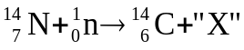 [  ] Proton/hydrogen nucleus
  - 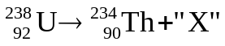 [  ] alpha
  - 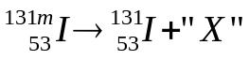 [  ] Gamma
(note: m denotes in excited state)
- The cyclist below is travelling to the right, but slowing down to stop at an intersection. Air resistance is significant. Draw and label all the vectors representing the forces acting on the cyclist. [4 marks]
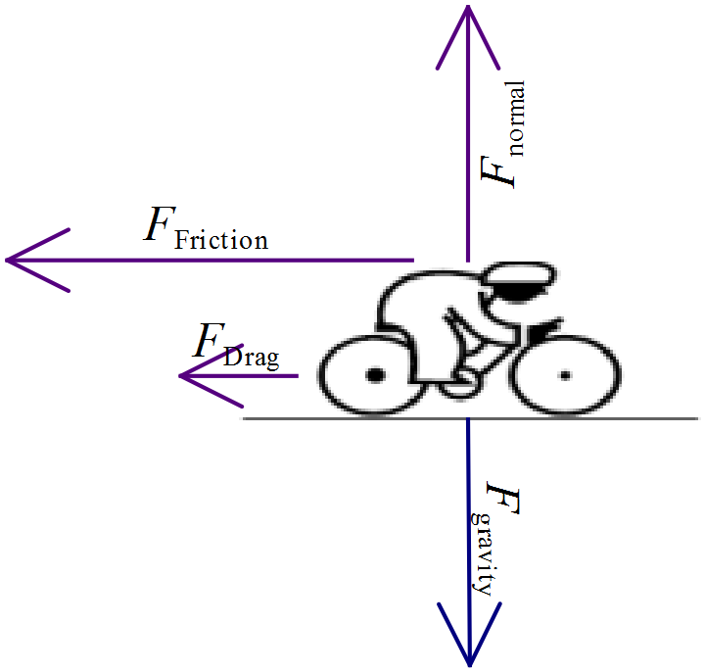 1 mark each vector with label ( -½ if no label)

- Following are two reactions that may occur in a nuclear reactor. Fill in the blanks to balance the following fission reactions.

  - 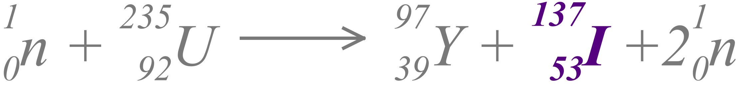 [1 mark]

  - 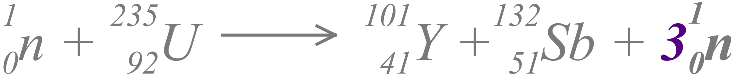 [1 mark]

  - With reference to the periodic table, explain why the fission fragment
Nb-101(in part b above) is not a stable nuclide: [2 marks]
The ratio of Protons:Neutron is about 1:1.5. Greater than the ratio of 1:1.25 [1] that would be expected for this atomic number.
Too many neutrons, so unstable. [1]
  - Explain the role of a moderator in a nuclear reactor which uses U-235 as a fuel. Why is it necessary? Give an example of a substance used as a moderator [3 marks]

Moderator slows down neutrons [1]
Needed because U-235 fission will not be triggered by a neutron with too much velocity/K.E. [1]
Water/Heavy water/Graphite are used [1]
- Gerald cycles from his home to a friend’s house along the path shown below:

  - When he arrives, what is his displacement from home? [1 marks]

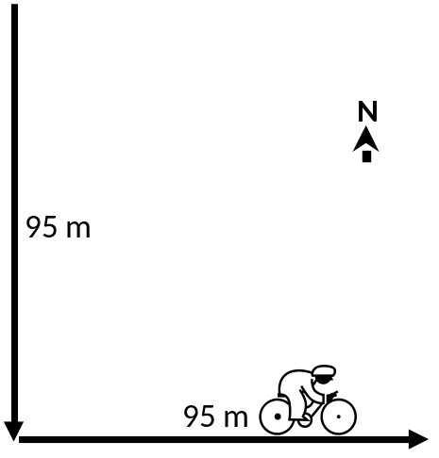

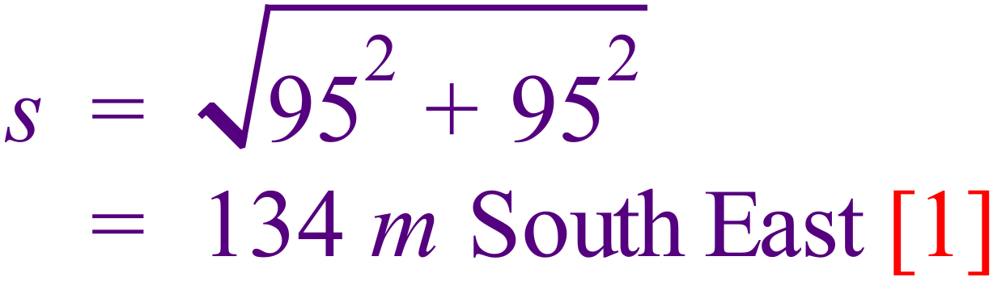
(-½ mark if no direction)

  - If the trip took 2 minutes, what was his average speed (in ms⁻¹) [1 mark]

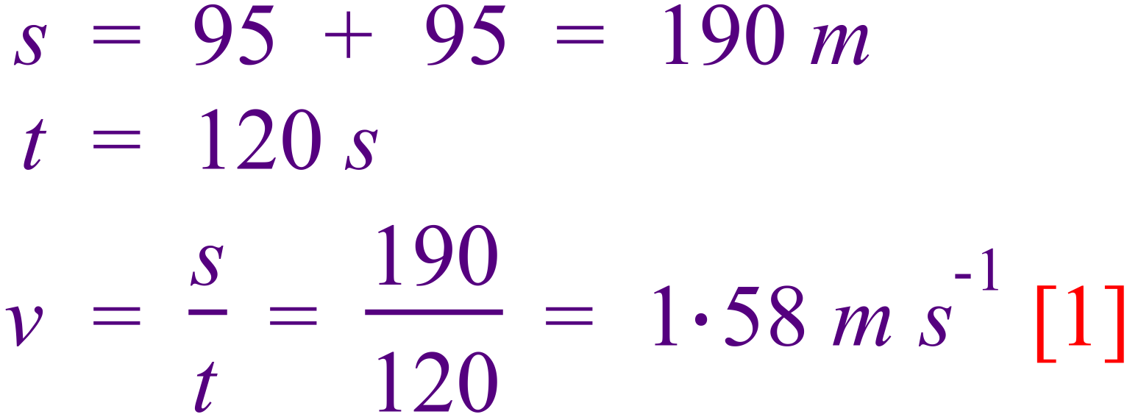

  - What was his average velocity for the trip? [2 marks]

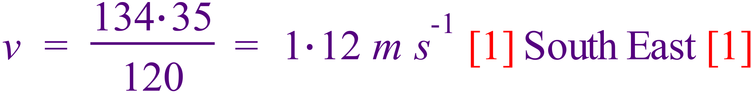

- A laboratory technician seals a pure sample of nitrogen-18 in an evacuated glass tube. Three days later she analyses the contents of the tube and finds that it contains some oxygen-18 even though the seal on the tube was not broken and the tube was air-tight.
Explain the most likely reason that the tube now contains some oxygen-18 and write an equation which describes the change. [3 marks]

The nitrogen-18 is an unstable isotope [1].
So it decays to form another element (oxygen-18) [1]

- A car of mass 1.50 x10³ kg is at rest when the driver accelerates so that the impulse produced by the engine is 2.00 x 10 ⁴ N s.
  - What would be the value of the velocity of the car after this initial acceleration? [2 marks]

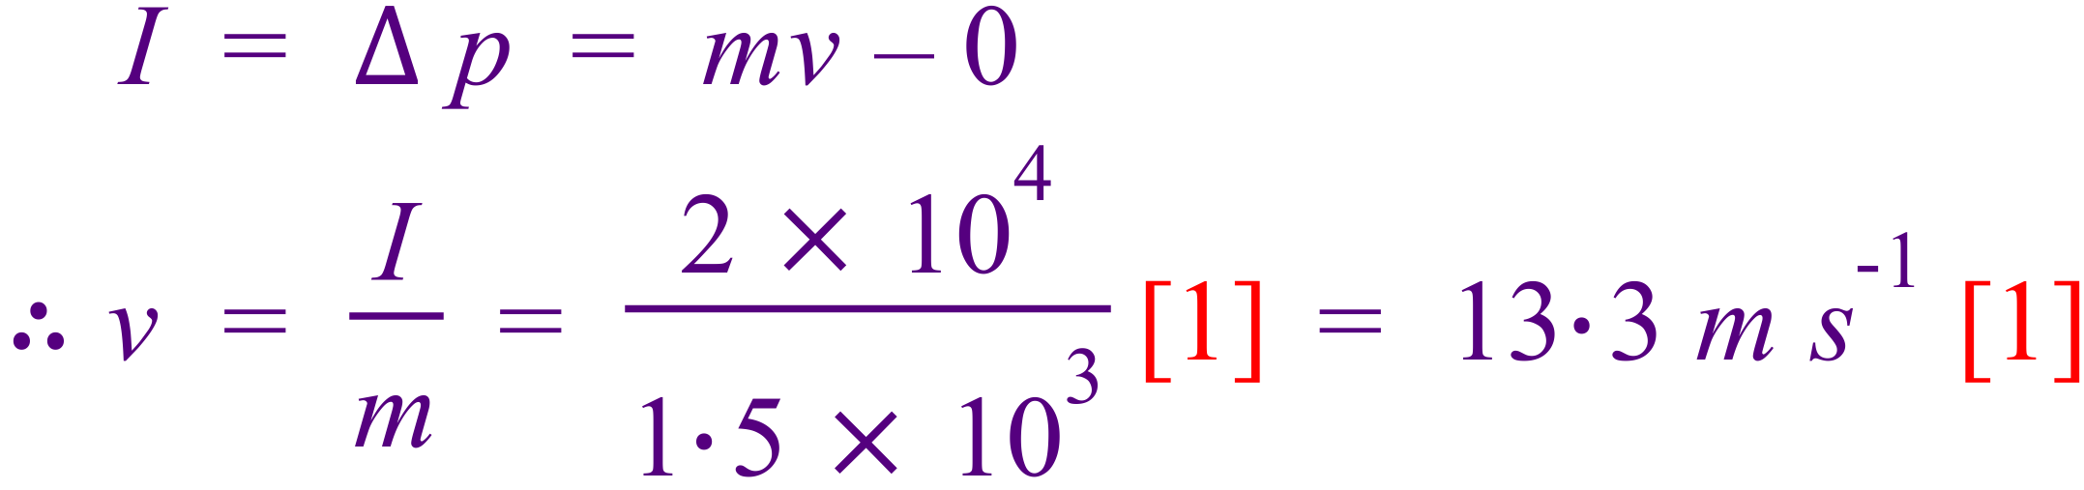

  - Calculate the kinetic energy of the car after the impulse from the engine has been applied. (If you couldn’t do part a) of this question, use a value of 12.0 ms⁻¹ for the car’s velocity). [1 mark]

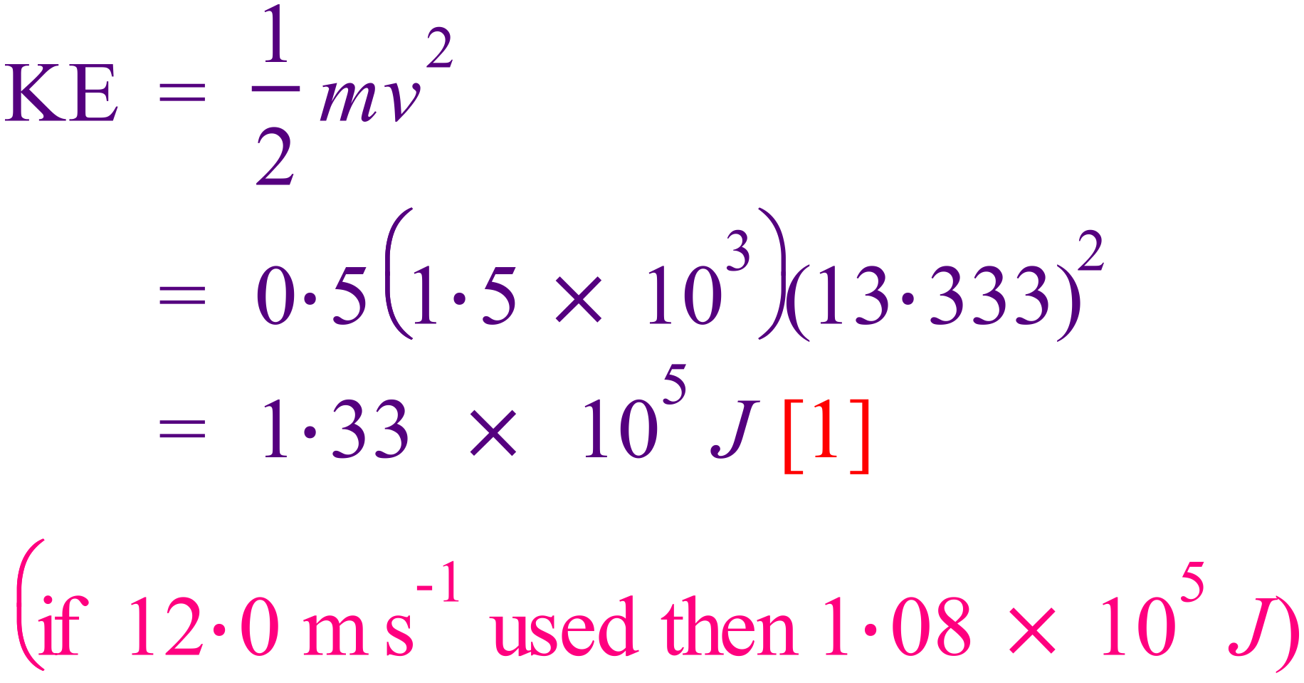

- World champion 200 metre bicycle sprinters can develop enormous power in their legs whilst maintaining a top speed of around 78.0 km h⁻¹. If a 70.0 kg rider maintains a constant force on his bike from his legs of 1.25 x 10² N over the whole 200 m track at a speed of 78.0 km h⁻¹, calculate a value for the power output of his legs.
[3 marks]

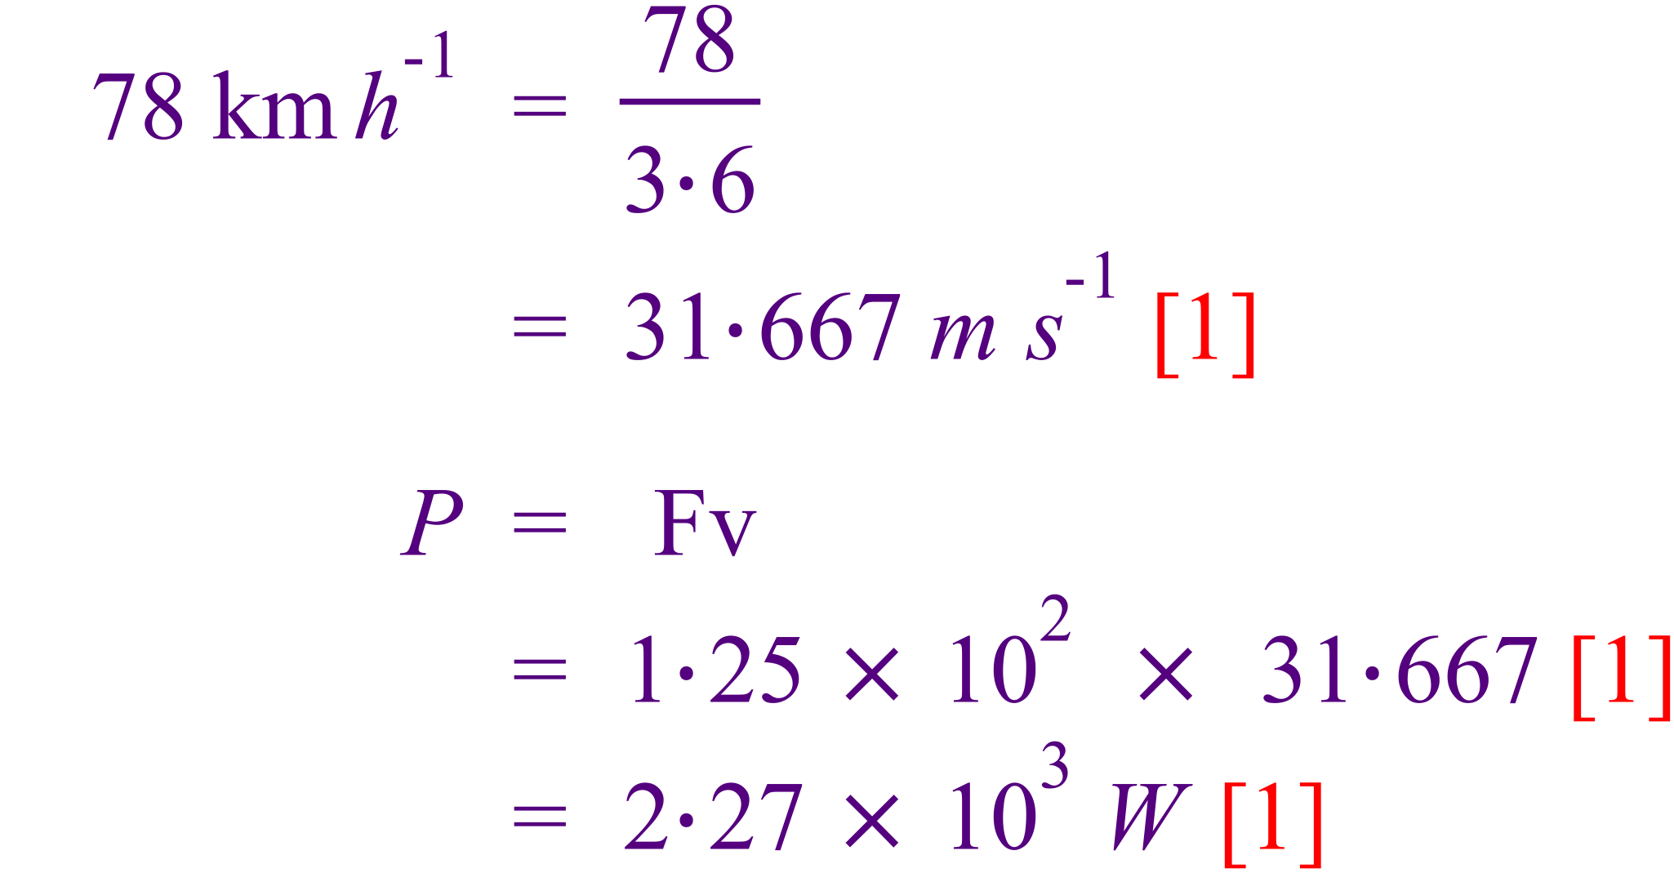
- In a football match, a player kicks a stationary football of mass 0.440 kg and gives it a speed of 32.0 m s^{–1}.

  - The contact time between the football and the footballer’s boot was 9.20 ms. Calculate the average force of impact on the football. [2 marks]
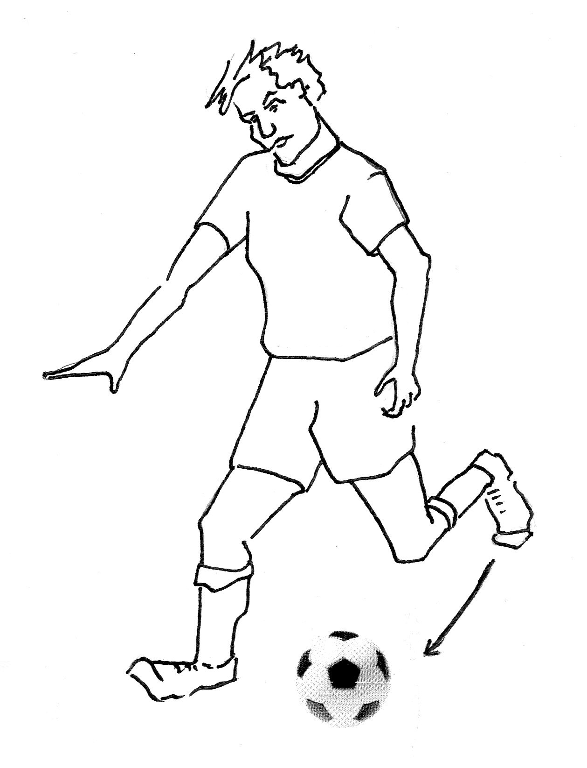
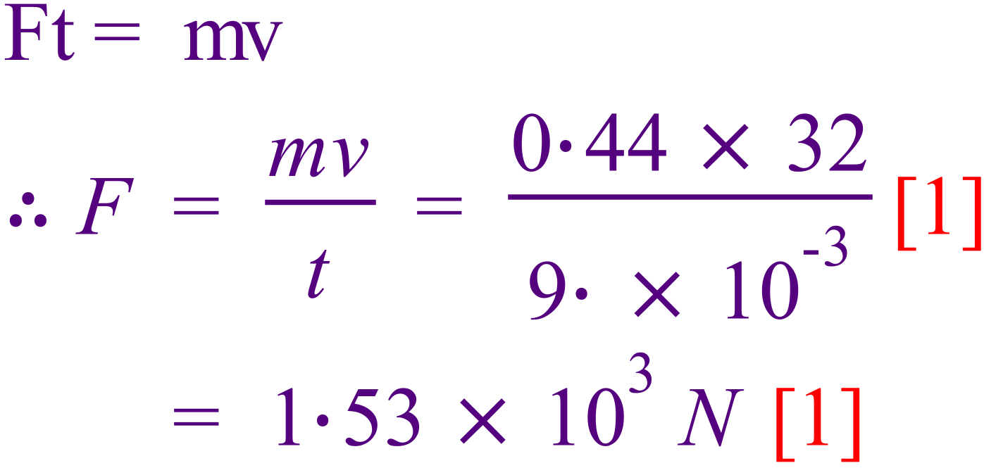

  - A video recording showed that the toe of the boot was moving along the straight line of the impact force when it struck the football. The force of the impact slowed the 1.60 kg boot down from a speed of 24 m s^{–1} to a speed of 15 m s^{–1}. Calculate the magnitude and direction of the change of momentum of the boot.
[2 marks]

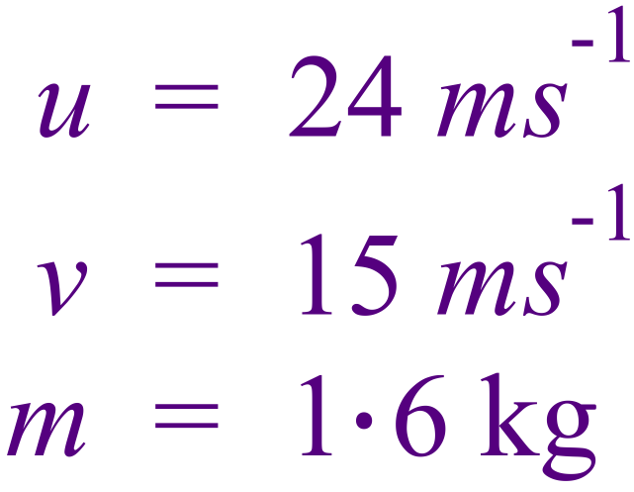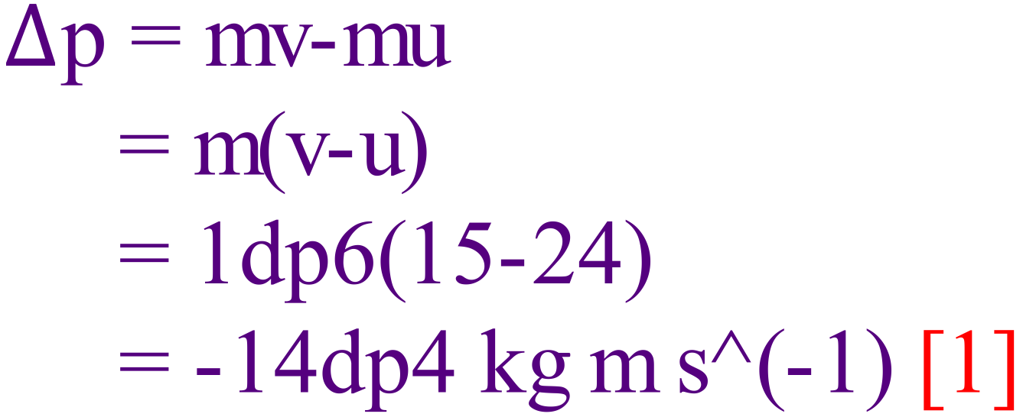
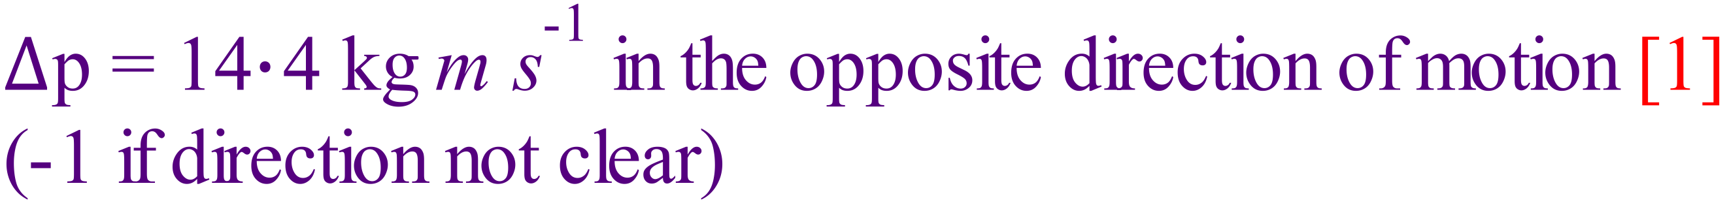
- A passenger lift of total mass 2.00 x 10³ kg moves between the ground floor and the top floor.
lift
Winching motor
lift cable
ground floor
top floor
At the moment shown in the diagram, the lift is moving downwards at a constant speed of 6.00 m s⁻¹.

The lift continues at this speed, then decelerates, and stops at ground level.

- What is the weight of the lift, in newtons, while it is moving downwards at a constant speed of 6.00 ms⁻¹? Show your reasoning. [2 marks]

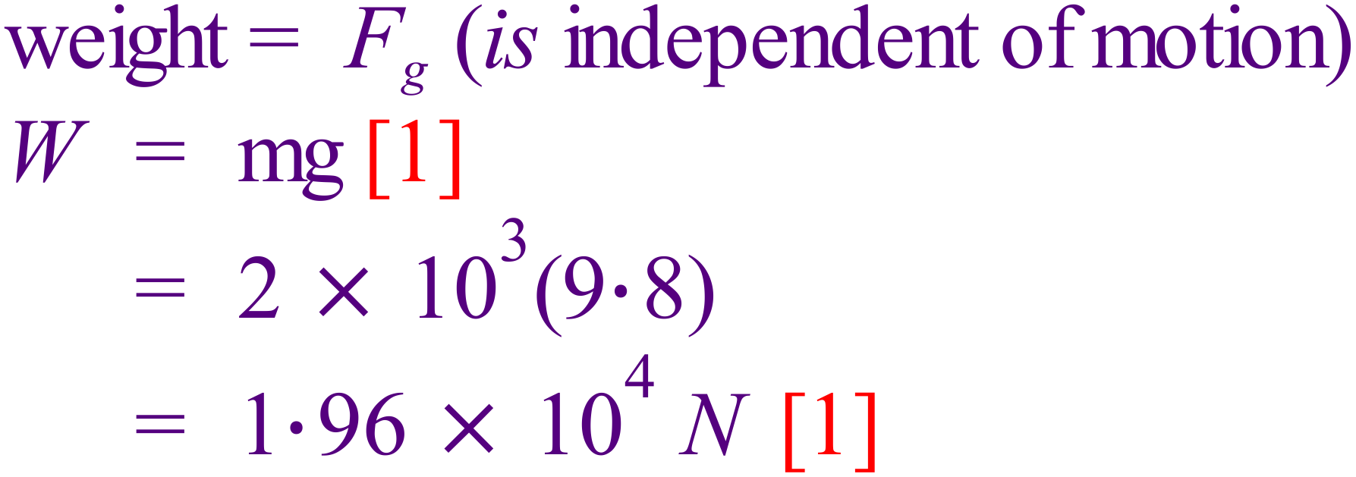

- Draw a free body diagram of the passenger if the lift is accelerating downwards.
[2 marks]
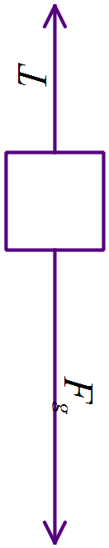 | 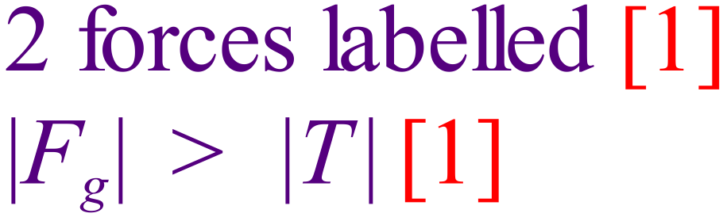

- Calculate the apparent mass of a 70-kg passenger if the lift accelerates downwards at 1.5 ms⁻²? [3 marks]
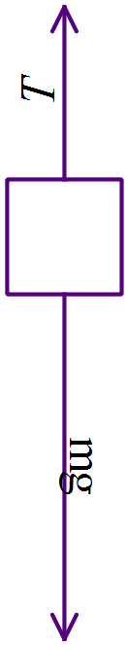 | 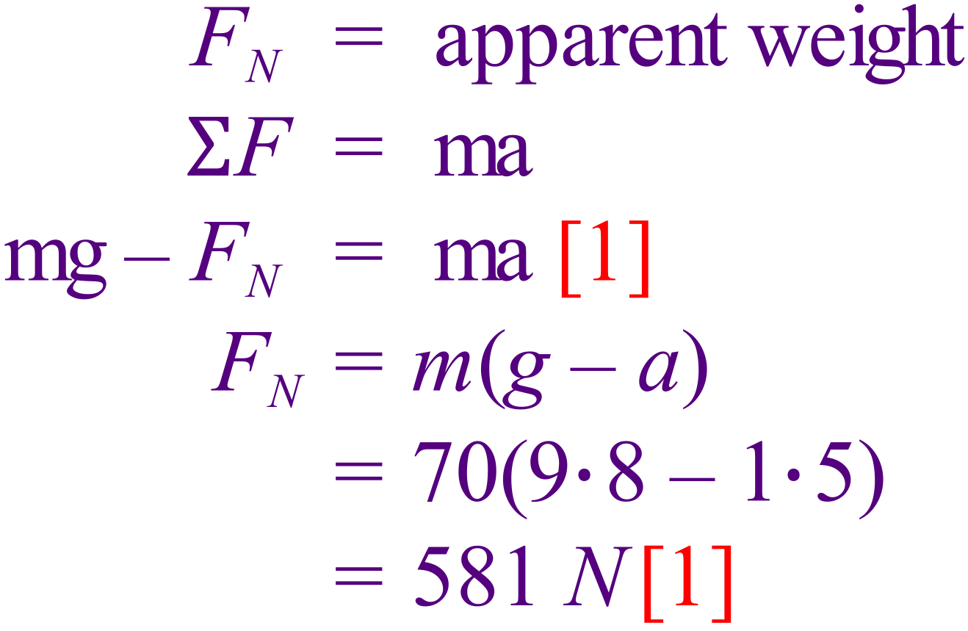 | 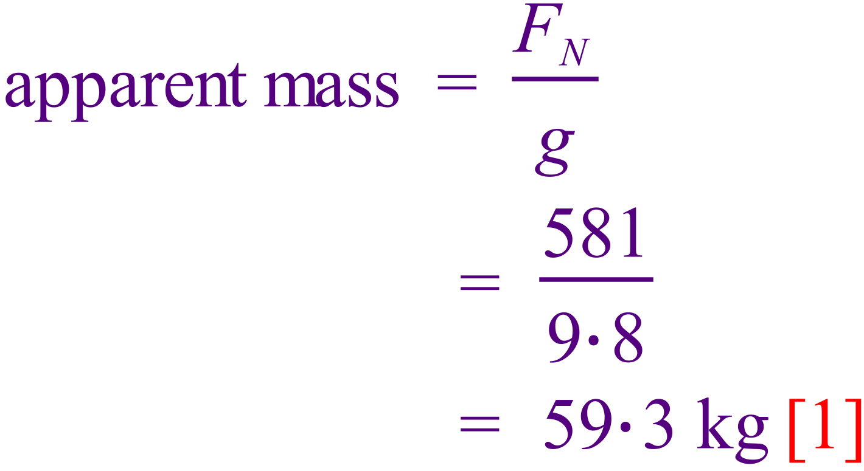
- Sam pushed a heavy crate from rest across a smooth (low friction) floor. The graph below shows how the force that Sam applied to the crate changed over time.
Force (N)
Time (s)
100
0
A
B
C
D

  - Between which points was the acceleration of the crate greatest?

Circle the correct answer: AB BC CD [1 mark]

Explain your answer: F = ma [1], so acceleration is highest when F is highest [1]

[2 marks]

  - Did Sam transfer any energy to the crate as he pushed it?

Circle the correct answer: Yes No [1 mark]

Explain your answer: W = Fs [1] and Sam maintained a force on the crate as he moved it a certain distance [1]
or
The fact that the crate was moving meant It had K.E. [1], gained from Sam [1]
[2 marks]

- A truck driver on the top of a hill releases the hand brake whilst in neutral gear, so that the truck rolls 100 m down the hill to a level emergency sand track. The hill has a slope of 25.0º to the horizontal and the truck’s mass is 6.50 tonnes.
Emergency sand track
25⁰
100 m

  - Calculate the speed of the truck at the bottom of the hill. [3 marks]
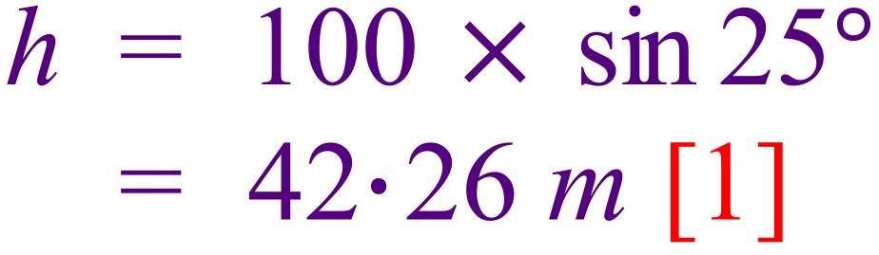
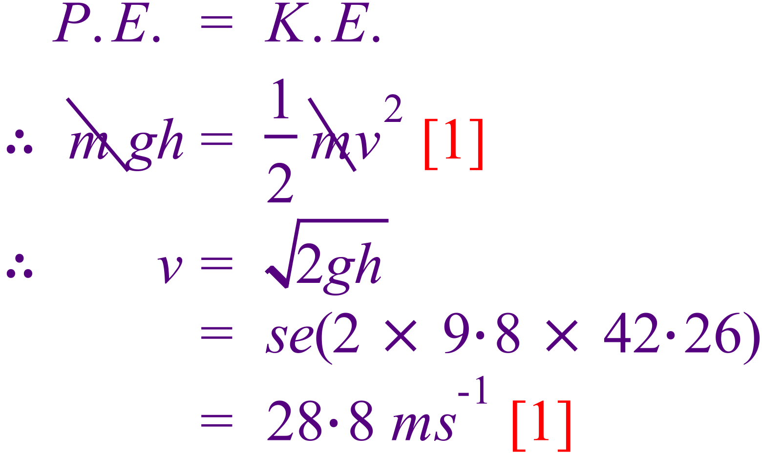

When the driver reaches the bottom he realizes that his brakes have failed, but luckily there is an emergency track made of sand which has been made to stop runaway trucks coming down the hill.
  - If the sand in the emergency track has a resistive force of 55.0 kN against the wheels of the truck, calculate the distance the truck travels in the sand (in the horizontal direction) before it stops. (If you couldn’t do part a of this question, use a value of 30.0 m s⁻¹ for the truck’s velocity). [3 marks]

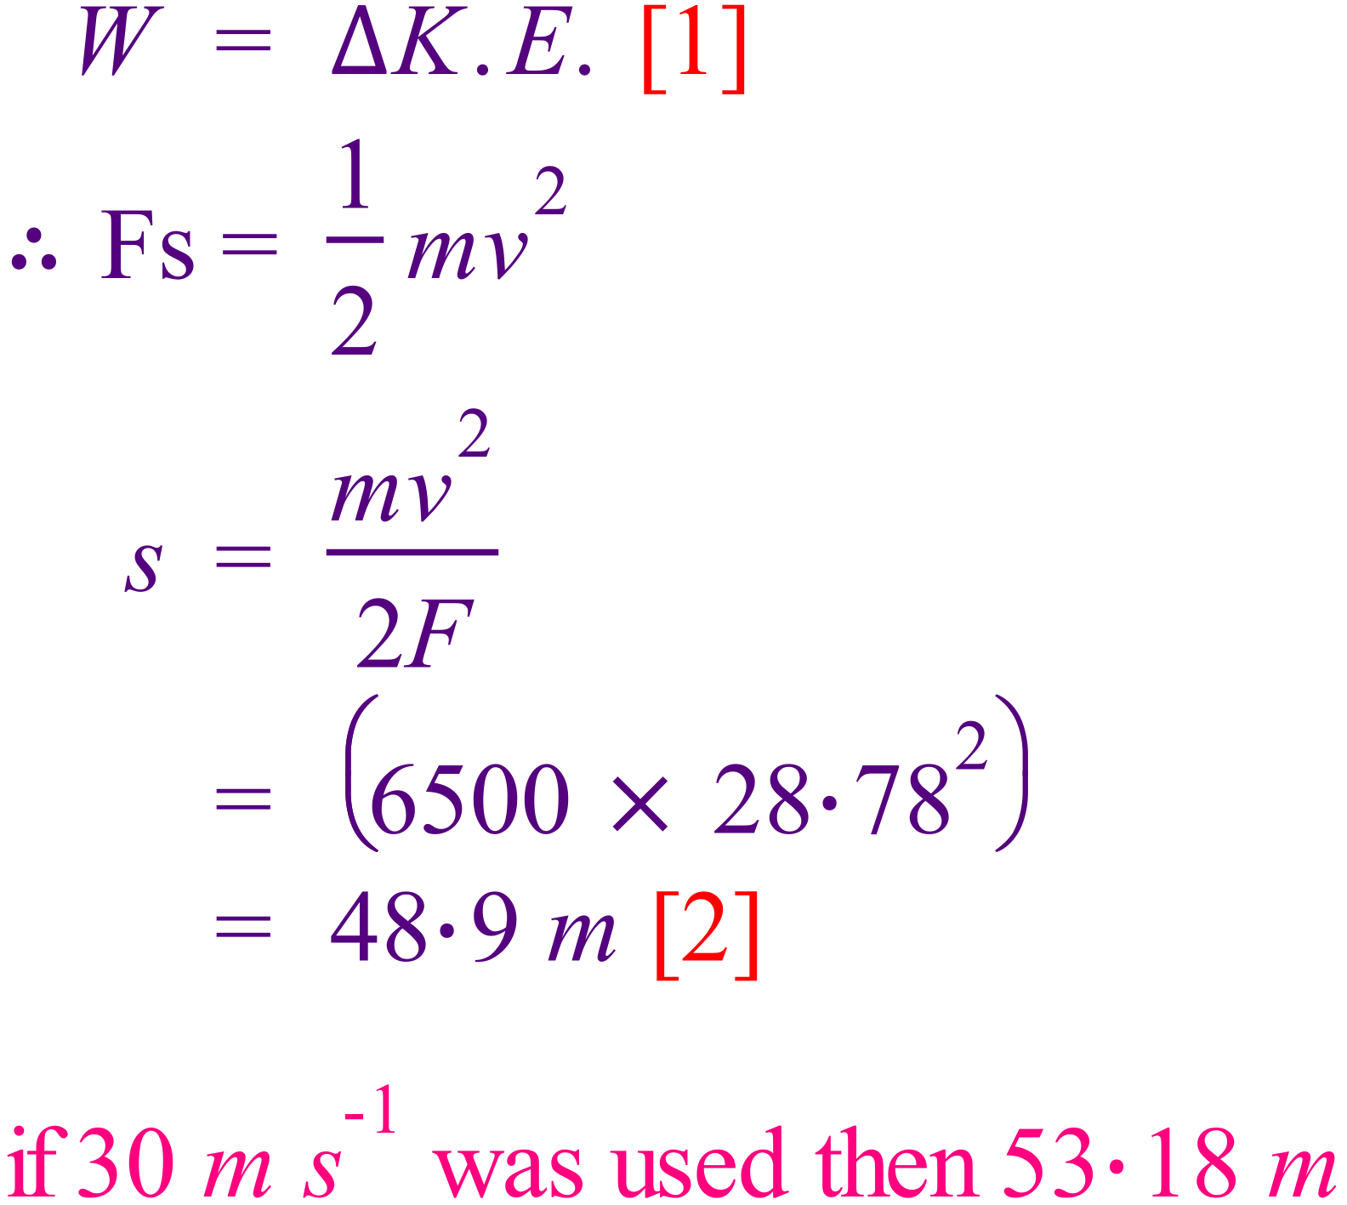

- The graph below shows how the displacement of a toy train moving in a straight line varies over a period of time.
(s)

  - What is the maximum speed attained by the train? [1 mark]

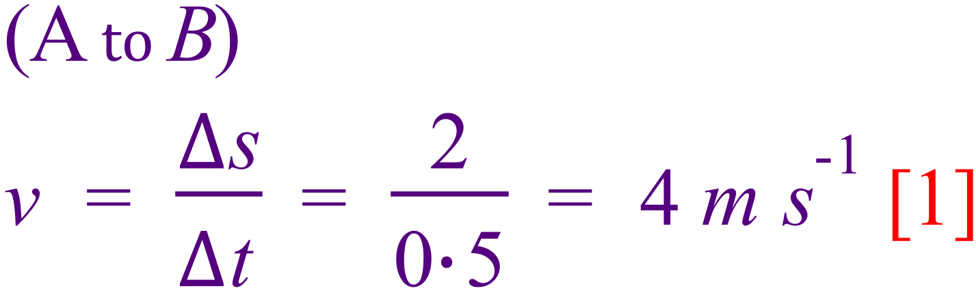
  - Describe the motion of the train in section
(i) BC
Stationary [1]
(ii) E [2 marks]
Constant v, (returning to origin, negative v) [1]
  - What is the total length of track used by the toy train in the above journey as shown by the graph? [1 mark]

3 m

END OF SECTION 1

This page has intentionally been left blank
Section Two: Problem-solving 45% (58 marks)
This section has 6 questions. Answer all questions. Write your answers in the spaces provided.
Suggested working time: 70 minutes

- (8 marks total)
  - Melinda likes playing cricket for her school. During a school match, she swings her new 2.20 kg bat forward to strike a 0.350 kg ball that is bowled towards her at 22.5 ms⁻¹. Her bat is moving towards the ball at a speed of 8.50 ms⁻¹ before it strikes the ball and the bat slows to a speed of 4.50 ms⁻¹ forwards after the ball has been hit.
Calculate the speed with which the ball leaves the bat after it has been hit. [3 marks]


8.50 m s⁻¹
22.5 m s⁻¹

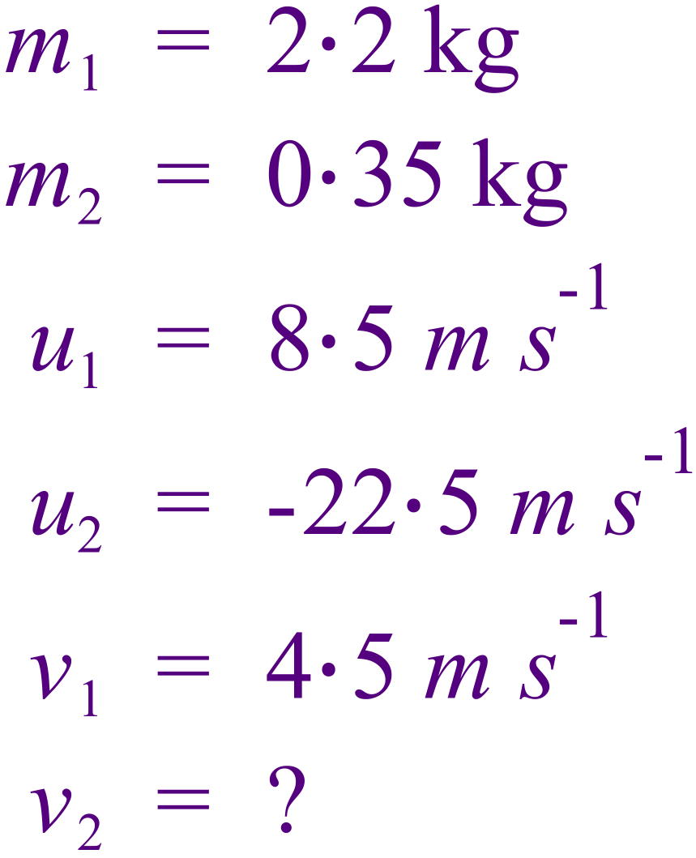 | 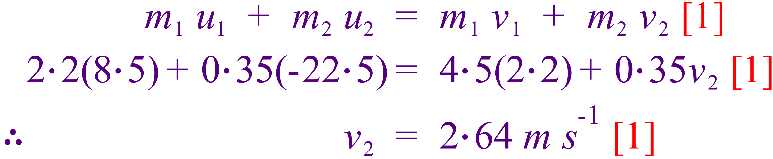
Note: direction not important as questions stated that the ball “leaves the bat”

  - Jim has a mass of 55.0 kg and jumps down from his garden wall 2.00 m high onto the ground landing safely by bending his knees. What is Jim’s momentum just before he lands? [3 marks]

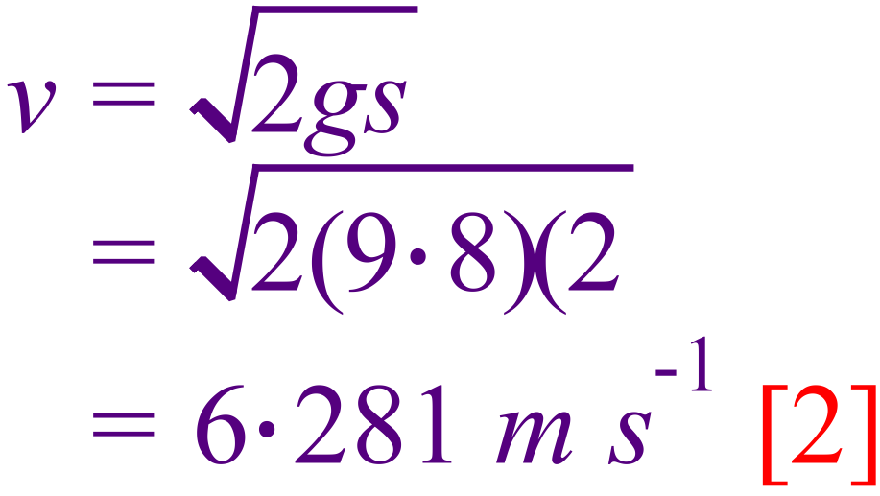 | 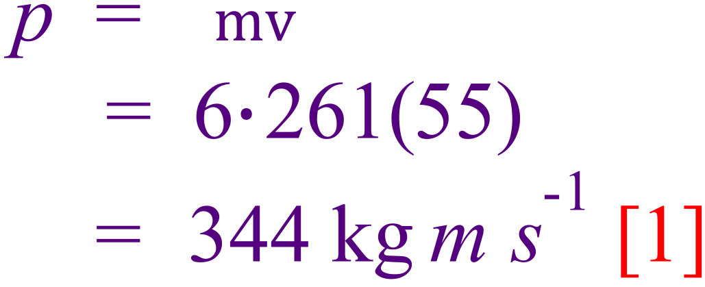

  - Explain, in terms of physics, how bending his knees makes the force acting on him smaller whilst his change in momentum remains the same. [2 marks]
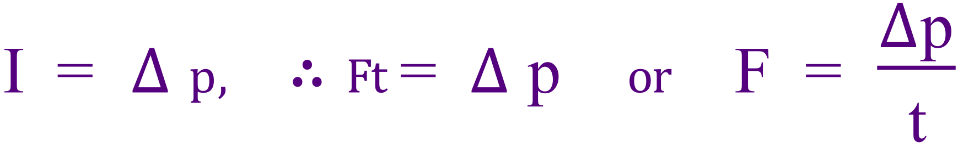
Change in momentum will be the same regardless of how he lands. [1]
However, bending knees extends time of impact, thus lowering maximum force [1]

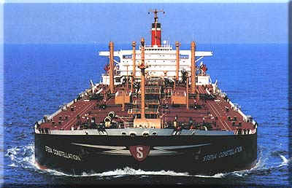
- (10 marks total)
A supertanker of mass 4.00 x 10⁸ kg takes 1.00 hour to reach its cruising speed of 14.5 m s⁻¹ when starting from rest Assuming that the net force accelerating the tanker is constant;
  - Calculate the acceleration of the tanker. [2 marks]

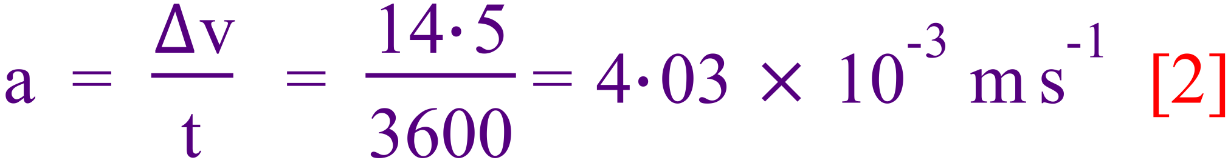

  - Calculate the total impulse acting to accelerate the tanker [2 marks]

  - What distance will be travelled by the tanker before it reaches full speed? [2 marks]

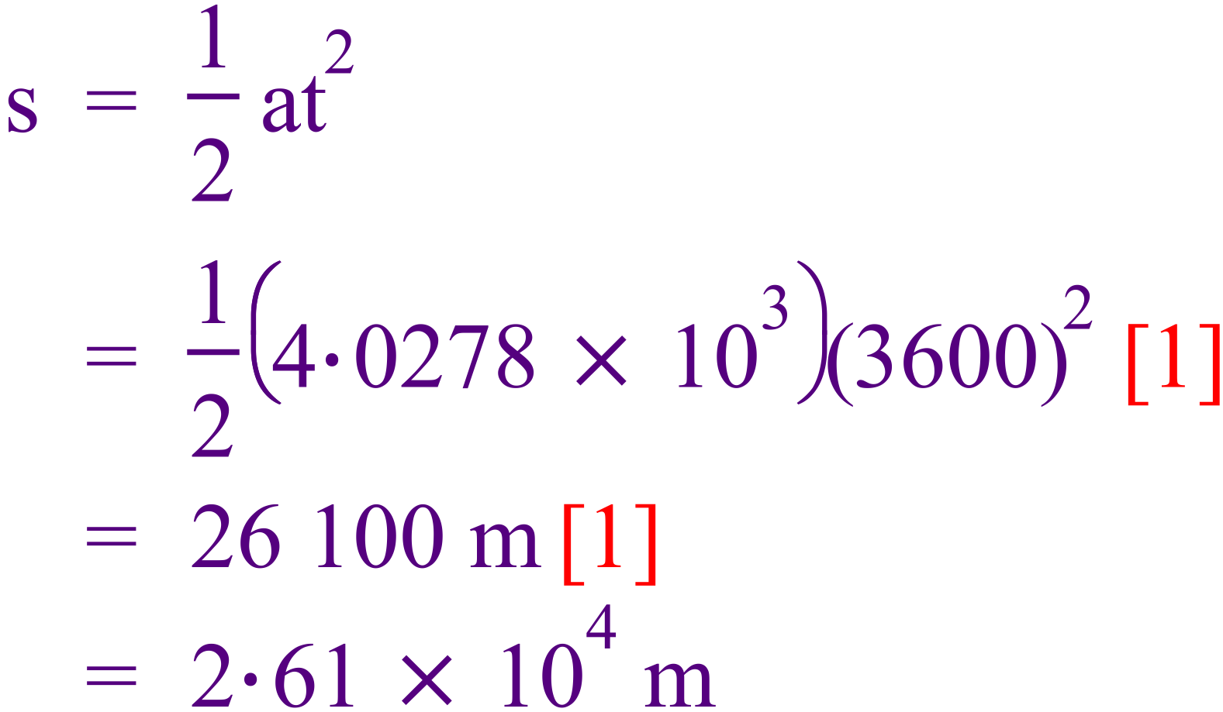

  - Once the tanker has reached 14.5 m s⁻¹, it continues at this constant velocity. 40 minutes after the tanker leaves port, a sailor who was left behind hires a small speed boat to catch up to the tanker. The speed boat averages 18 m s⁻¹.

    - How far from port will the speed boat be when the tanker finishes accelerating?
[1 mark]
After 20 min = 1200 s

    - How long in total will it take the speed boat to catch up with the tanker? (i.e starting from the time the speedboat leaves port). [3 marks]
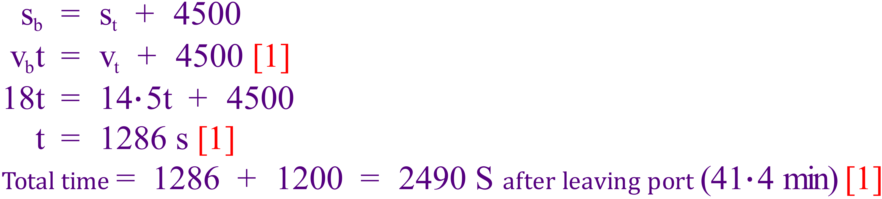

- .(11 marks total)
  - Carbon-14 dating is a method used to estimate the age of wooden artefacts in tombs and other locations. An archaeologist found a 100-gram wooden statue in an ancient cave. A sample of the statue has an activity of 0.021 Bq. The count from a 300-gram modern sample of the same wood has an activity of 1.02 Bq. Estimate the age of the statue if the half life of carbon-14 is 5730 years. [4 marks]
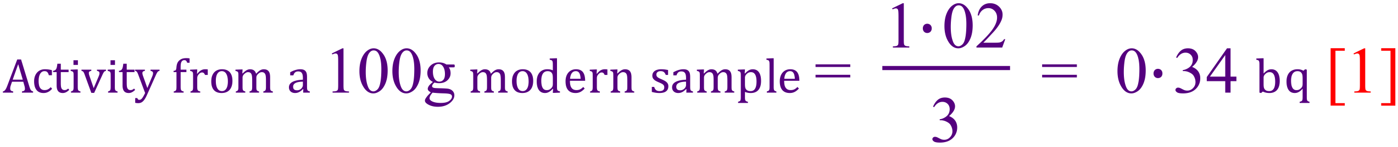

(Question 16 continued)
  - Within the cave was also found gold jewellery and a stone arrowhead. Why was the statue chosen to date the tomb and not the jewellery or the arrowhead.
[2 marks]

C-14 dating only works for organic substances [1]
Because they must contain carbon which the jewellery and arrowhead do not contain [1]

  - A radioactive source is used to test the thickness of paper. The source is put on one side of the paper and the Geiger counter on the other side. The paper travels from the papermaking plant through the rollers as shown.
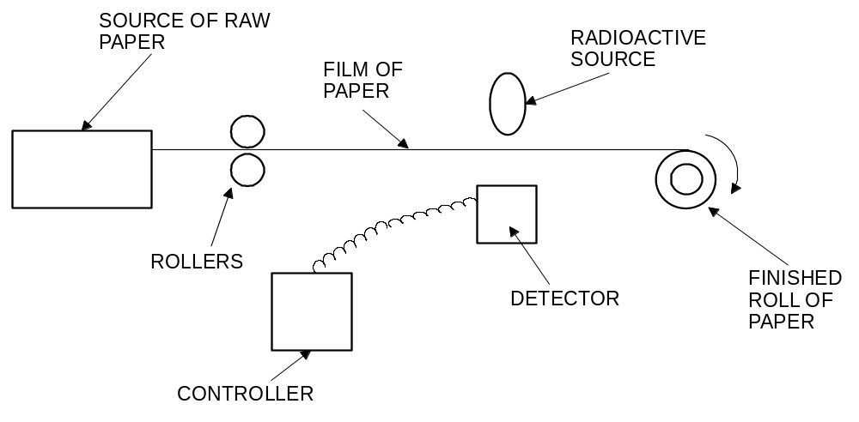
PAPER MAKING PLANT

GEIGER COUNTER

    - Why are beta particles more suitable than alpha particles or gamma rays for this job? [2 marks]
α will not penetrate (0% penetration) [ ½ ]
γ will not be affected (100% penetration) [ ½ ]
β penetration will depend on thickness of paper [1] giving a useful reading [1]
(Question 16 continued)
The table shows the reading on the counter during 70 s.
times in seconds | 10 | 20 | 30 | 40 | 50 | 60 | 70
total count since the start | 50 | 100 | 150 | 195 | 235 | 275 | 315
count in 10 seconds | 50 | 50 | 50 | 45 | 40 | 40 | 40

    - Look at the table of results. What happened to the thickness of the paper? Explain. [2 marks]

It got thicker. Less β penetrating after 30 s suggests thicker paper [2]

    - The isotope used in the above process has a half life of 5.50 years. If a new sample of the isotope used has a count rate of 1500 counts per minute and is only useful with count rate over 190 counts per minute, approximately how long will the isotope sample last before it needs to be replaced? [2 marks]

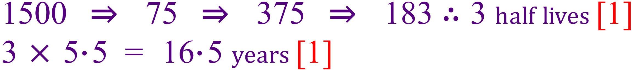

- (11 marks total)
In an experiment to determine the half-life of the element protactinium a small amount of protactinium nitrate solution was placed in a petri dish and the β-particle emission from the liquid was measured using a Geiger Counter.
235.0
Geiger Counter
Petri dish
Particle counter

The Geiger Counter was connected to an electronic particle recorder that displays the total number of counts of β-particles coming from the protactinium source, measured every 25 seconds.
The experimental results are shown in the table below.
Column A | Column B | Column C | Column D
Time (s) | Total Count | Count for each 25 s | Count Rate
25 | 233 | 233 | 9.32
50 | 418 | 185 | 7.40
75 | 570 | 152 | 6.08
100 | 687 | 117 | 4.68
125 | 775 | 88 | 3.52
150 | 860 | 85 | 3.40
175 | 933 | 73 | 2.92
200 | 1005 | 72 | 2.88
225 | 1055 | 50 | 2.00
250 | 1123 | 68 | 2.72
275 | 1160 | 37 | 1.48
300 | 1203 | 43 | 1.72
325 | 1241 | 38 | 1.52
350 | 1273 | 32 | 1.28
 |  | [1] | [1]

- Complete Columns C and D in the table so that Column C shows the counts recorded in each 25 second interval and Column D shows the count rate i.e. the count per second. (The first four have been completed for you.) [2 marks]
- Using Columns A and D, construct a graph on the grid below. Plot Count Rate or Count per second (y-axis) against Time (x-axis). [5 marks]

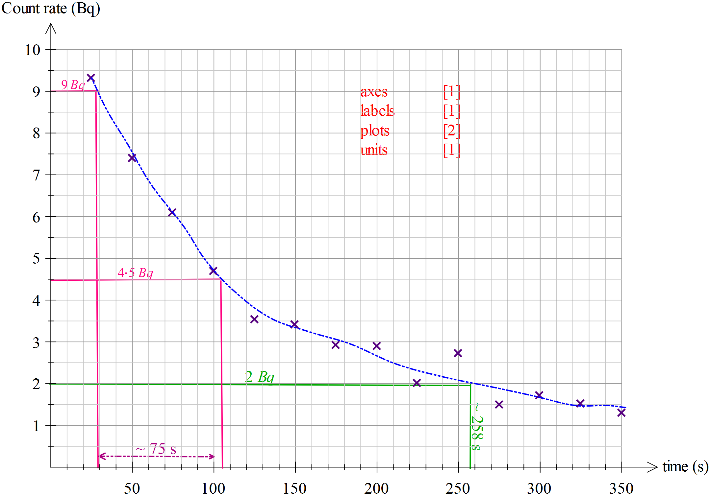

- Using your graph, determine the half life of the protactinium isotope. Show your working on the graph. [2 marks]

ANSWER: 75 s ± 10
- Using your graph, estimate the elapsed time for the counter to record a rate of 120 counts per minute. Show on your graph how you got this result. [2 marks]

ANSWER: 258 s ± 2 (120 counts per min = 2 count per second)
- (7 marks total)
A sample of potassium contains enough of the radioactive isotope 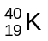 to emit radiation with a total energy of 1.00 x 10⁻⁹ J each second. This isotope has a long half-life, so its energy output does not change significantly over one year.

  - Calculate the total energy the sample radiates over a one year period. [2 marks]

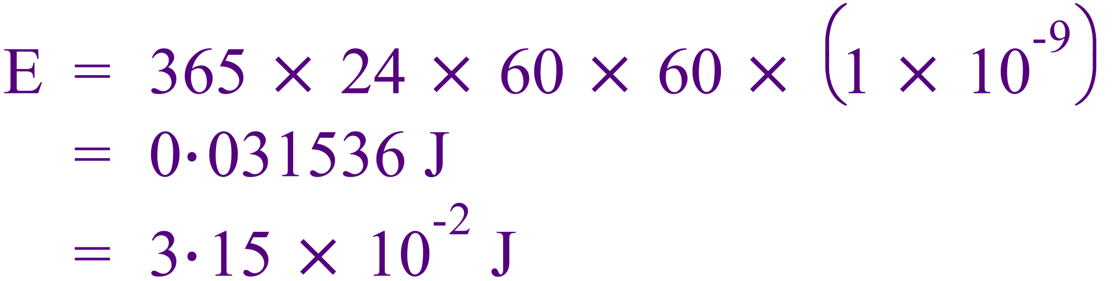

  - If this energy is absorbed by a 75.0 kg man, calculate his whole-body absorbed radiation dose over one year. Give your answer in the appropriate units for radiation dose [2 marks]

  - Potassium-40 is a rare example of a radioisotope which emits both alpha and beta radiation. If approximately 90% of the energy emitted is via beta radiation and the remaining amount is alpha, calculate the total dose equivalent for the 75-kg man. [3 marks]

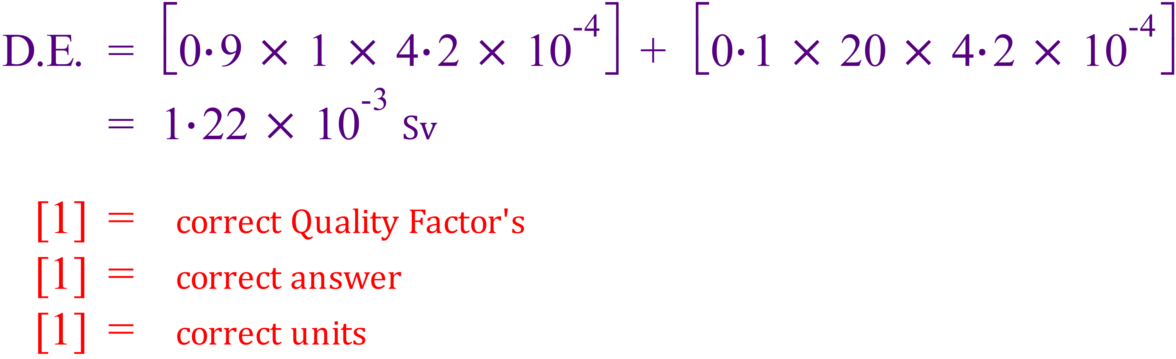

- (10 marks total)
A roller coaster at a festival is set up by a carriage being hauled to the top by an electric motor. The total mass of the carriage and the people is 505 kg and the vertical height is 31.0 m. 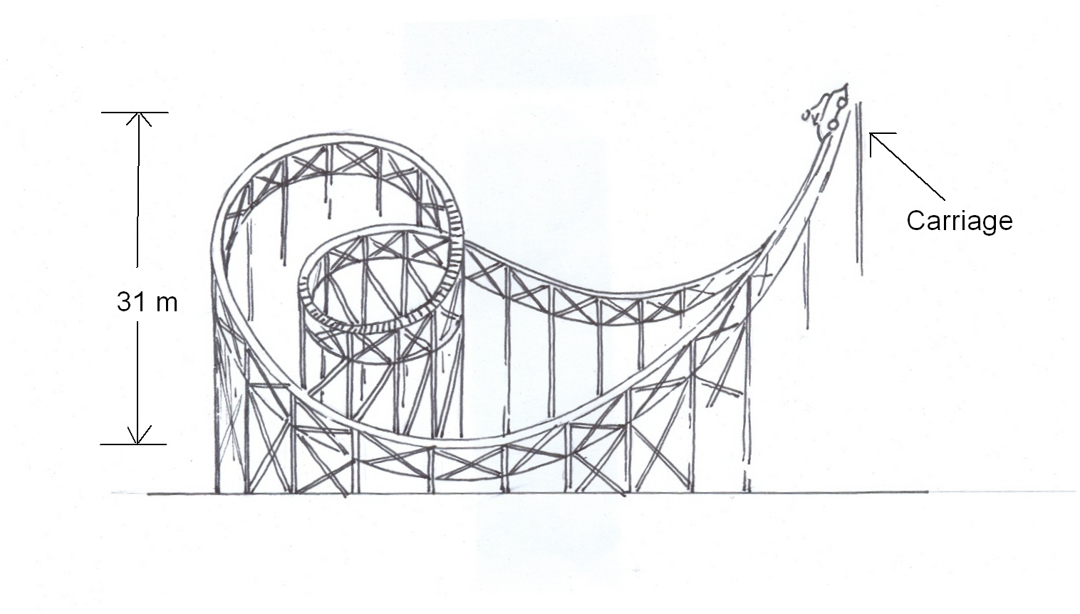
31.0m
360° loop
  - Calculate the potential energy of the carriage at the beginning of the ride.
[2 marks]
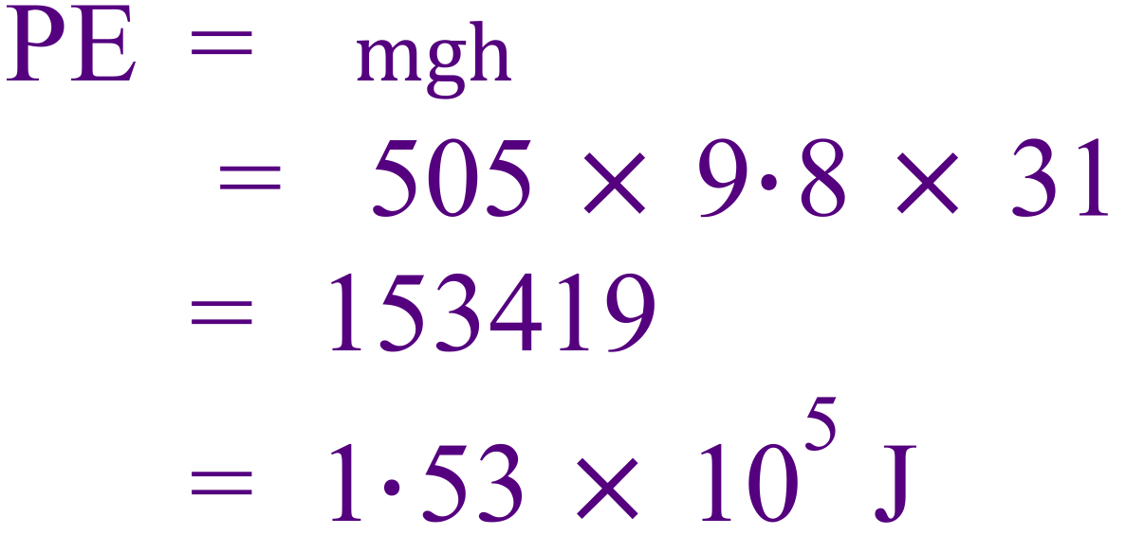

  - The car is then released and goes down a slope that is 70.0 m long, where the average frictional force is 80.0 N. What is the speed of the carriage when it reaches the bottom? [4 marks]

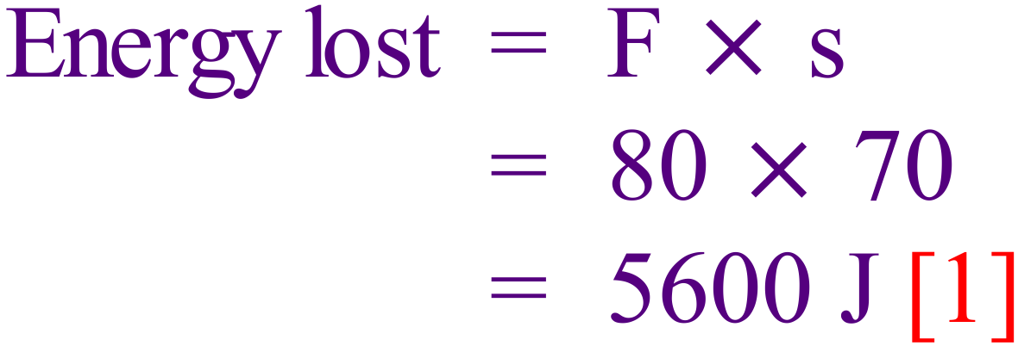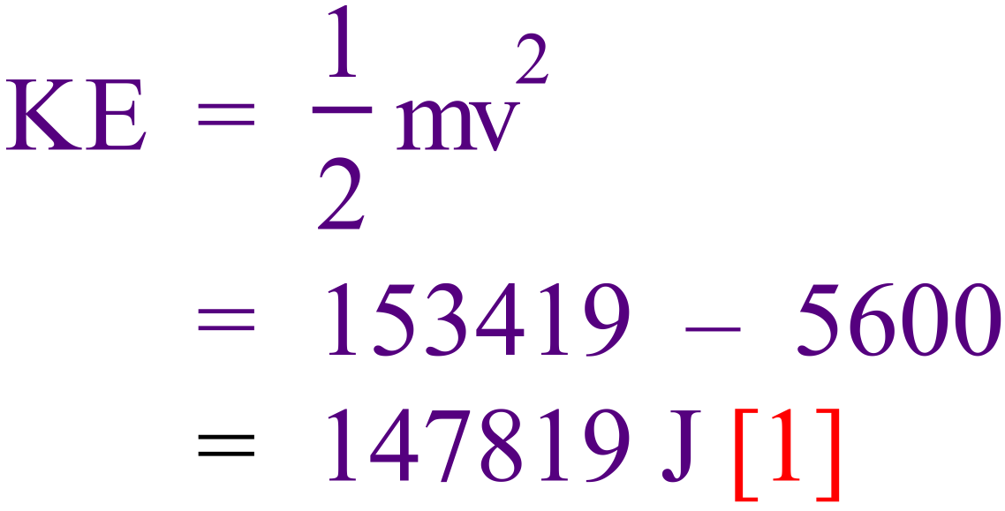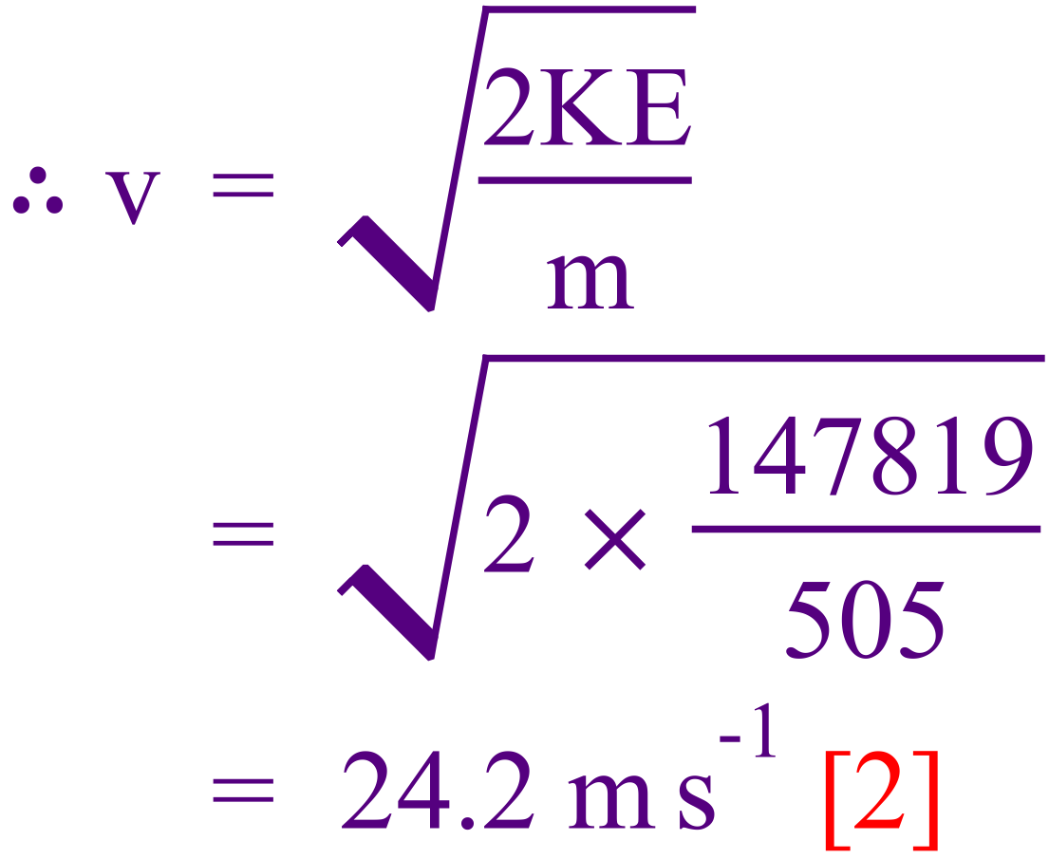

  - Calculate the momentum of the carriage at the bottom of the slope. [2 marks]

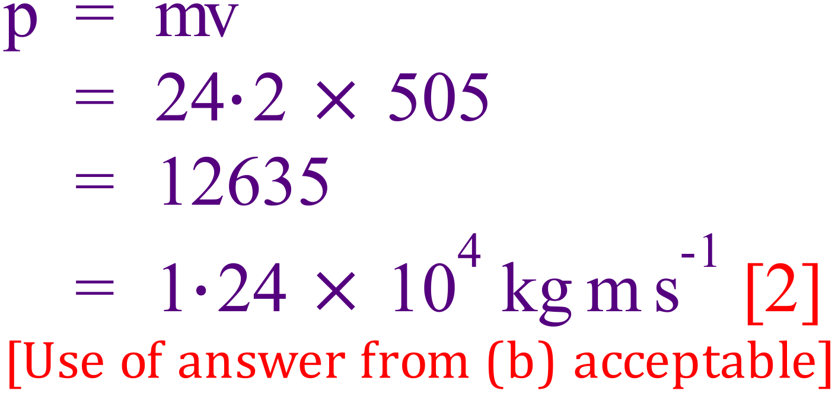

  - The diagram shows a 360° loop on the ride that is lower in height to the beginning of the ride, where the carriage was released. Briefly explain why this is necessary. [2 marks]

If frictionless, then the carriage could in theory reach the same height at another part of the track (31 m) due to the Law of Conservation of Energy [1].
However it must be lower than 31 m because of the energy lost to friction [1]

END OF SECTION 2
Section Three: Comprehension 12% (15 Marks)
This section contains one (1) question. You must answer this question. Write your answers in the spaces provided. You are reminded of the need for clear and concise presentation of answers. Diagrams (sketches), equations and /or numerical results should be included as appropriate.
Suggested working time: 25 minutes.

- Sudden Stop

(Paragraph 1)
Vehicles are not intrinsically dangerous: let's face it, you are most unlikely to have an accident if your car never leaves your driveway. Which tends to prove that it is the movement that causes all the problems. You see, as soon as your vehicle moves it comes under the influence of a variety of physical forces, some good for you, some bad. Things like momentum, kinetic energy, centripetal force, gravity, drag, directional force, etc.

(Paragraph 2)
The worst of that lot is kinetic energy, a function of the speed and loaded mass of the vehicle. This kinetic energy increases proportionally with the square of your speed. In other words, when you triple your speed (for example when you go from 30 km h⁻¹ to 90 km h⁻¹) your kinetic energy increases 9 times (3x3). This is not good because your braking distance will increase 9 times when you increase your speed 3 times. (Please note that I am not talking about the total stopping distance, as this would include the driver's thinking distance).

(Paragraph 3)
You probably realise what this means in practical terms: if you hit at 90 kmh⁻¹ the crash is going to be 9 times worse than it would be at 30 kmh⁻¹. However if you take this a bit further, you will see that something good comes out of it. If faced with any crisis, wipe as much speed off the car as you can. So, you see that firstly (before taking evasive action with the steering wheel), you have to decrease your speed as much as you can - without locking the wheels - and then you must try to avoid a hard landing. Given a choice, a clump of bushes is preferable to a parked car, and hitting the back of a parked car at 60 km h⁻¹ will be pretty much the same as hitting a brick wall at half that speed.

(Paragraph 4)
Above all, never hit a tree!! Trees are the most unforgiving things that you may come up against in anger. There is no "give" in them and you concentrate the whole force on a narrow profile. And of course, make sure that your loads are secure, the baby is in the baby capsule on the back seat, and you and your passengers are all correctly buckled in.

Questions
- Use equation(s) to verify the claim that the "braking distance increases 9 times when the speed increases 3 times". (Assume that the braking force is constant.)
[2 marks]

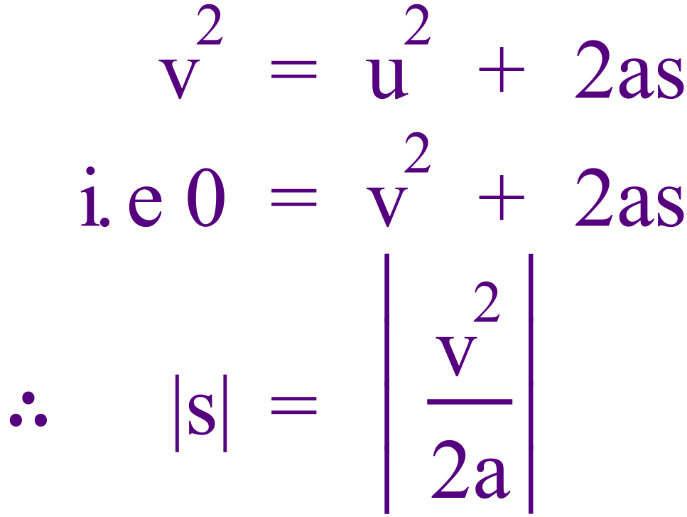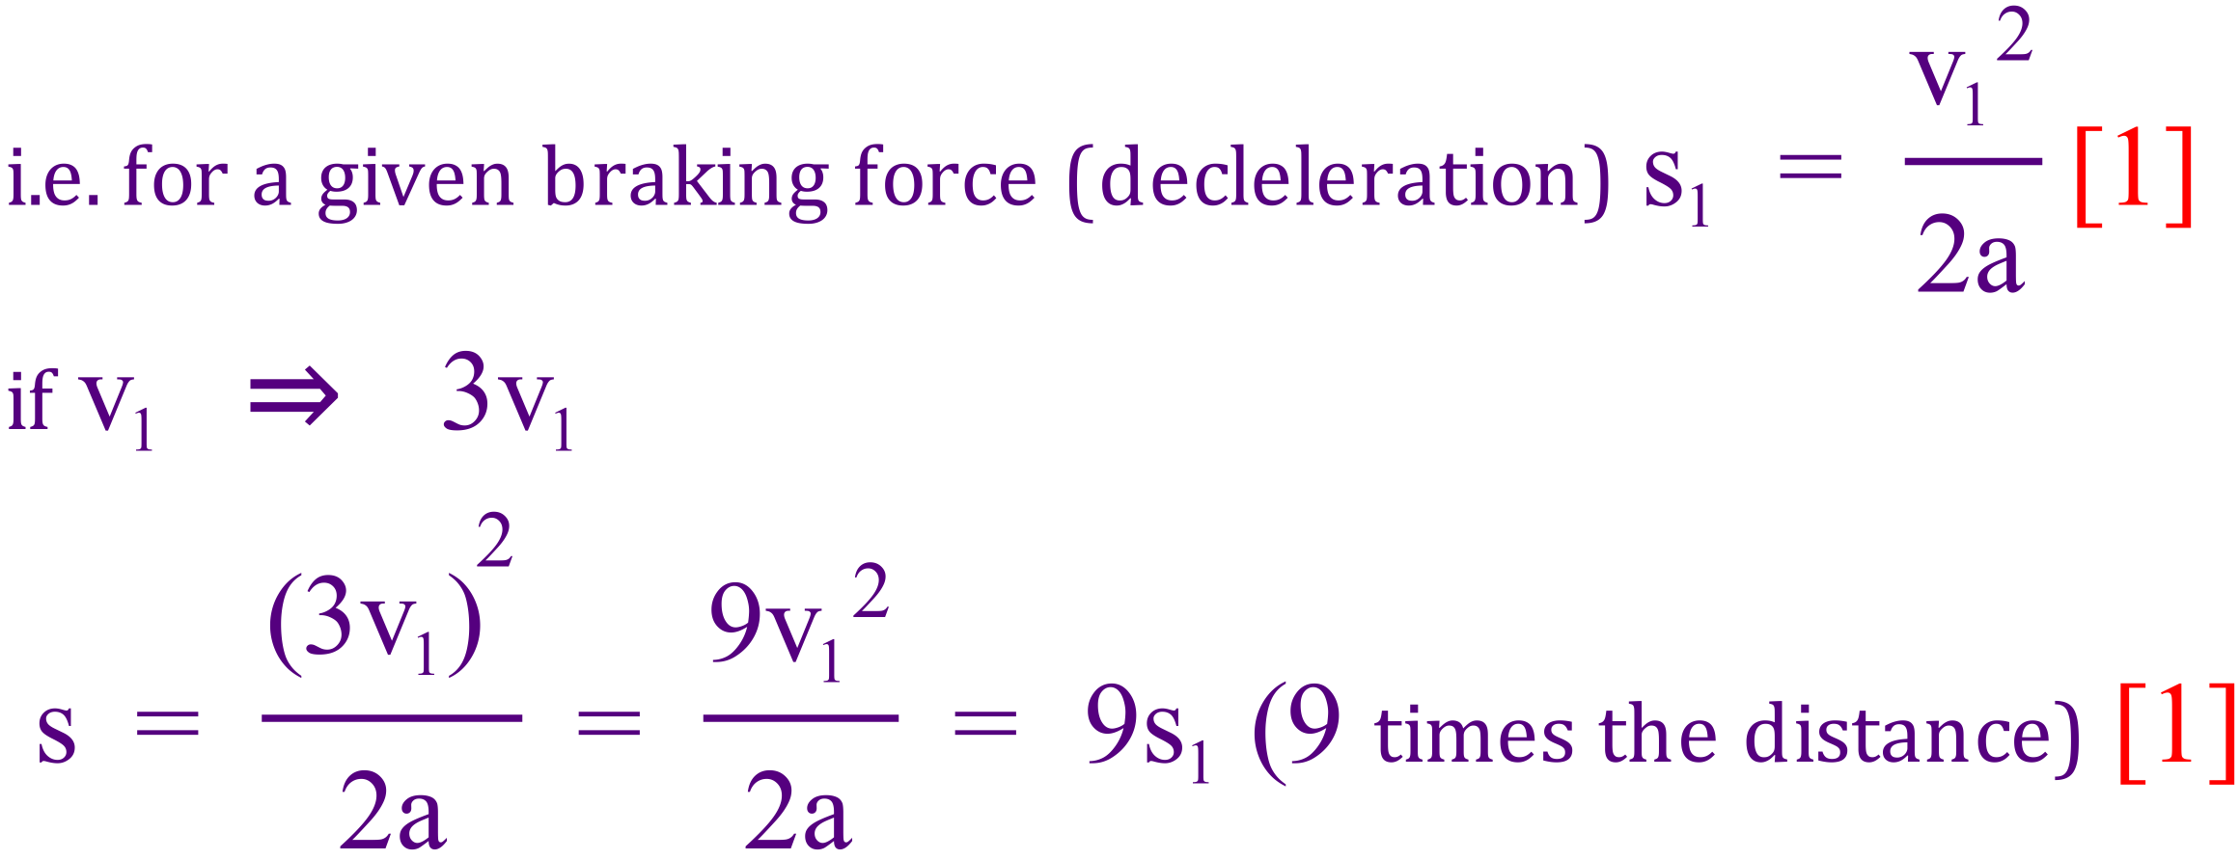

- What is ‘driver’s thinking distance’ and how does this distance vary when speed in increased? [2 marks]

It is the distance travelled between the time the driver sees an emergency and applying the brakes [1].
It is proportional to velocity [1] (since s = vt for constant velocity)

- Using the equations of motion, write an expression for the total stopping distance in terms of the initial speed u, driver reaction time t_{r} and the car’s deceleration rate a
[2 marks]

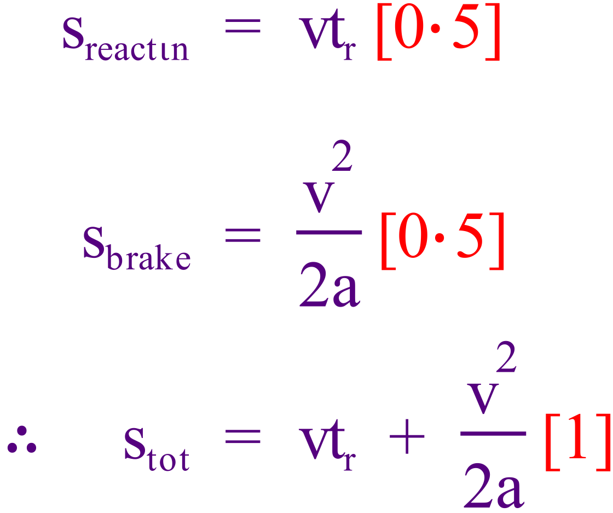

- Explain the Physics behind the claim that loads should be secured in a moving vehicle. [3 marks]

Newton’s first law says that objects will continue moving at constant velocity unless acted upon by a net unbalanced force [1].
If a vehicle stops suddenly, there will be no significant force to slow unsecured loads [1]
They will “fly forward” an could cause injury [1]

- Fully explain how design features such as “crumple zones” use the concept of impulse to reduce the severity of injury to drivers in the event of a collision.
[4 marks]

 is the impulse needed to bring an object to rest [1]
If time is increased, the the impulsive force (F) is reduced [1]
A crumple zone is designed to extend the collision time by collapsing ‘slowly’, reducing the acceleration & forces [1]
Lower forces result in less injury [1]

- Use physics principles to explain why hitting a very solid brick wall or a large tree is likely to be much more damaging to the car and its occupants than hitting a parked car. [2 marks]

A parked car will ‘give’, meaning it will move when another car crashes into it [1].
This extends the time of collision, reducing net acceleration, thus reducing the max/average force [1].

END OF EXAMINATION

Alternate graph for Q.17

